Interpolation of values within hexahedral elements

Input:
x_{p}, y_{p}, z_{p} (coordinates of point P)
x_{e,1-8}, y_{e,1-8}, z_{e,1-8} (coordinates of element nodes 1-8)

Output:
w₁₋₈ (weight values 1-8 for nodal values)

Description:

Get local element coordinates (ξ-η-ζ system) ξ_{p}, η_{p}, ζ_{p} for coordinates of P:
Horizontal plane:
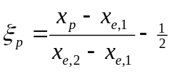
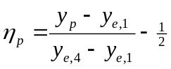

It should hold that
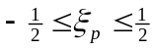, and
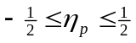
otherwise P is not within the horizontal boundaries of the element.

Vertical:
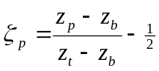

It should hold that
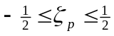
otherwise P is not within the vertical boundaries of the element.

Calculate weight factors:
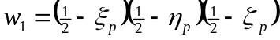
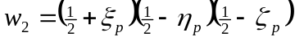
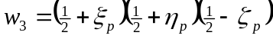
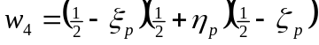
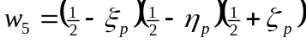
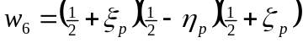
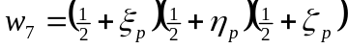
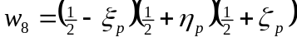

Given the result values r₁₋₈ in the nodes of the element, the result value r_{p} in point P can now be calculated using:
